Timeline of events – Coomera
1839 | Coomera River mapped by survey party and named the area Arrowsmith
1857 | First timber getters set up camp at Upper Coomera
1860 | The first European settlers began to settle in Coomera. Timber was rafted down the river.
1873 | First school was opened in Coomera on a private premises
1874 | First school at Coomera was built and opened with 22 students
1878 | Second provisional school opened at Baker’s Creek later the name changed to Upper Coomera (1880)
1879 | Provisional school opened at Maudsland
1884 | Coomera Shire Council formed
1887 | The Ferry across the Coomera River began service
1889 | The Railway was opened
1896 | Opening of the School of Arts
1930 | The Coomera Bridge opened – linking the coast road
1932 | Guanaba State school opened
1964 | Maudsland and Upper Coomera schools were amalgamated with Coomera School and students travelled to Coomera by bus
1964 | Railway closed
1982 | Dreamworld opened
1996 | Saint Stephens College opened
1996 | Railway reopened in current location
2000 | Four lane M1 highway from Brisbane to the Gold Coast is opened
2013 | Coomera Ambulance Station opened

Cut out and match the following pictures to events on the Coomera History Timeline

Aboriginals meeting with surveyors 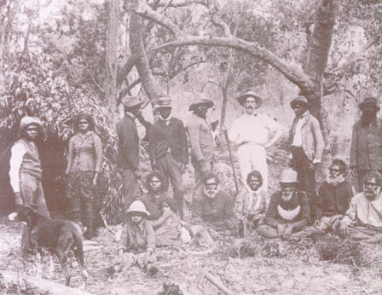 | 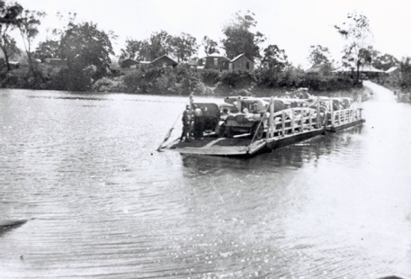  Coomera River Ferry | 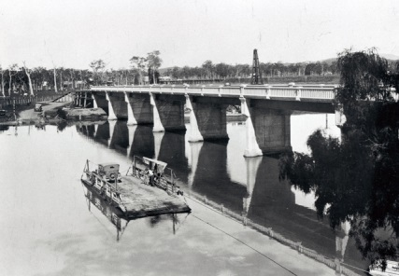  Coomera River Bridge | 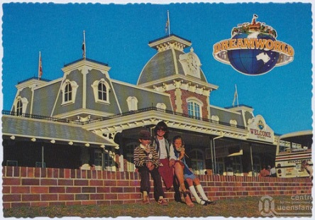  Dreamworld
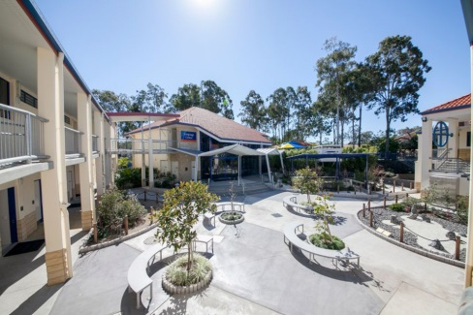  Saint Stephens College | 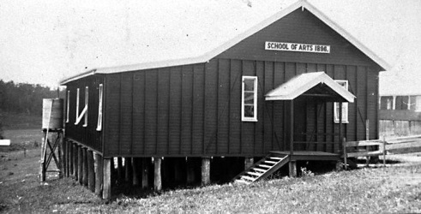  School of Arts | 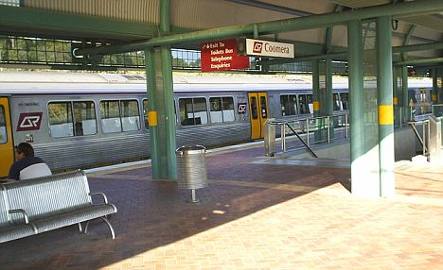  Coomera Train Station | 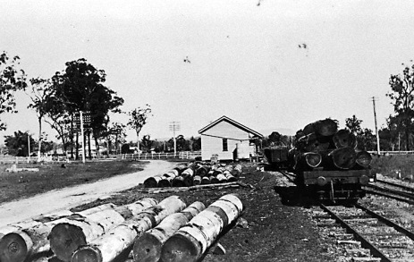  Coomera Train Station

