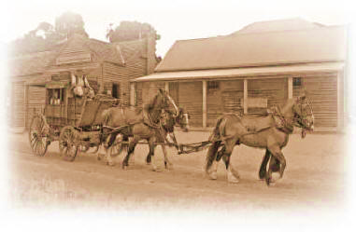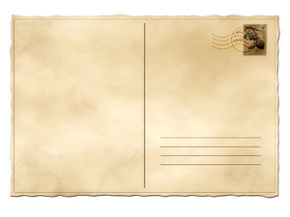

Dear Aunty Mary

I hope you are well. I miss seeing you and living in England.

It is hard living here in Queensland. It is very hot. It is hard to go anywhere because there aren’t many roads yet.

We have the horses and bullocks that came on the ships to help us go to places. The bullocks are strong and are good for pulling logs and stones to make houses and roads. We ride the horses and use them to pull carts and to work on the farm. They also bring us letters from you! We are lucky to have two horses on our farm.

I have heard that some people have brought camels from India to Australia! They are using them to go where there are no roads at all, into the bush and mountains.

Tomorrow, I am going into town on a coach. It is just like the ones in England, with four horses pulling a carriage that nine or so people can ride in at once. I’m going to take a ride in the coach. I hear it is very bumpy! The coach service is called Cobb & Co. They have lots of coaches and are helping many people travel to gold mines and across the land.

Yours fondly

Margaret