History | Year 3
Change in a community – School of Arts, Reserve Rd Coomera

Name: | Teacher:
Class: | Date:
Reserve Road Coomera, School of Arts in the past.
- Look at the visual source below to pose questions about the natural and built environment.
- Locate information in the visual source to answer your posed questions.

Question:
Answer:

Question:
Answer:

Question:
Answer:

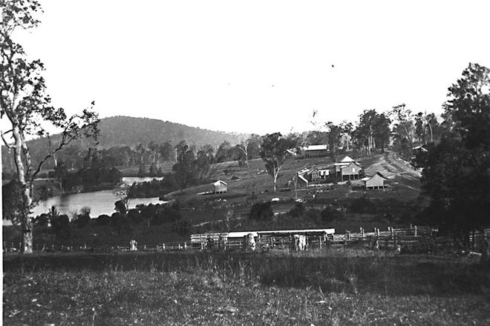

Reserve Road Coomera, School of Arts in the present.
- Look at the visual source below to pose questions about the natural and built environment.
- Locate information in the visual source to answer your posed questions.
Question:
Answer:

Question:
Answer:

Question:
Answer:

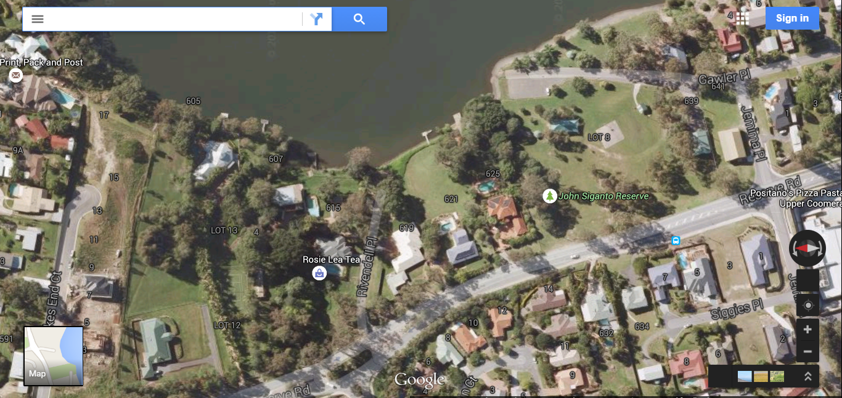

Part C: Compare the continuities and changes of the natural and built environment of Coomera over time by completing the table.
Hotel at Burleigh Heads 1900
Hotel at Burleigh Heads 2012
Hotel at Burleigh Heads 1900
Coomera in the past | Coomera in the present
What stayed the same? | What changed?

Pose a question about continuity and change in the natural and built environment of Coomera

Question:

Answer your posed question using the information in the table above and the photographs of the natural and built environment from the past and present.

Answer:

