History | Year 3
Assessment task — Collection of work: Change in a community

Name: | Teacher:
Class: | Date:

Task
To explain how a community changed in the past.
Instructions
Part A — Pose and answer questions about the past
- Research the natural and built environment of Oxenford in the past
Part B — Pose and answer questions about the present
- Research the natural and built environment of Oxenford in the present
Part C — Write a postcard - explanation
- Compare the continuities and changes of the natural and built environment of Oxenford over time
- Explain to a student in the past what changes in Oxenford natural and built environment over time have occurred
Conditions

- Students undertake research to write an explanation
- Undertaken individually in class time
- Students are able to seek assistance from their teacher regarding comprehension and interpretation of sources

Part A: Research the natural and built environment of Oxenford in the past.
- Look at the visual source below to pose questions about the natural and built environment.
- Locate information in the visual source to answer your posed questions.
Question:
Answer:

Question:
Answer:

Question:
Answer:

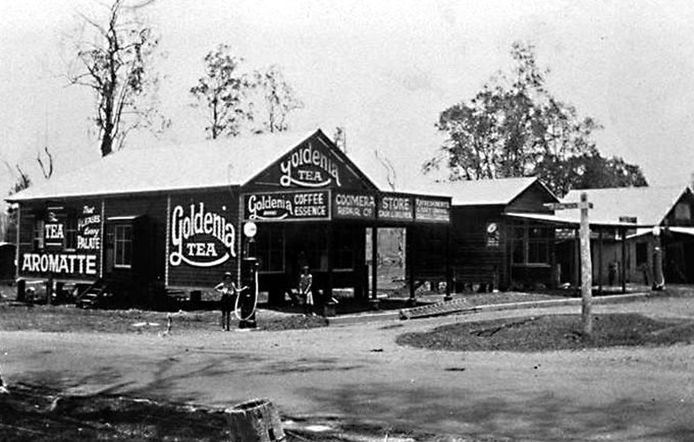
Ryder's store at the corner of the what was known as Upper Coomera Road (in the vicinity of Tambourine-Oxenford Road) and the Main Southport Road (later known as the Old Pacific Highway), Oxenford, Queensland, circa 1936.
Part B: Research the natural and built environment of Oxenford in the present.
- Look at the visual source below to pose questions about the natural and built environment.
- Locate information in the visual source to answer your posed questions.
Question:
Answer:

Question:
Answer:

Question:
Answer:

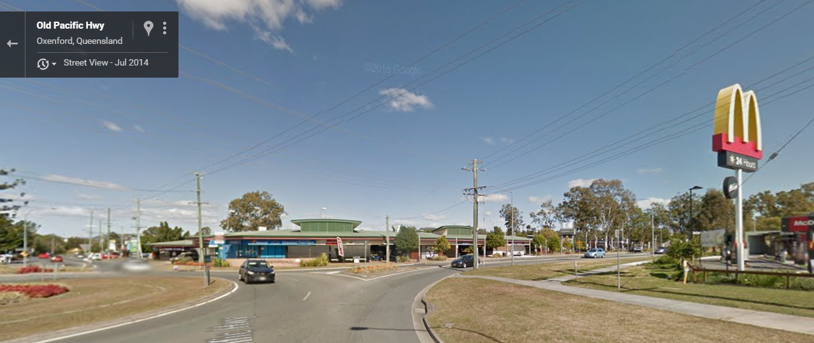
Google Maps street view Centro Oxenford –
Cnr of Old Pacific Highway and Tamborine-Oxenford Rd

Part C: Compare the continuities and changes of the natural and built environment of Oxenford over time by completing the table.
Hotel at Burleigh Heads 1900
Hotel at Burleigh Heads 2012
Hotel at Burleigh Heads 1900
Oxenford in the past | Oxenford in the present
What stayed the same? | What changed?

Pose a question about continuity and change in the natural and built environment of Oxenford

Question:

Answer your posed question using the information in the table above and the photographs of the natural and built environment from the past and present.

Answer:

Part C continued: Pretend you are a student at Coomera State School in the past. Use the information that we have discussed over the past lessons to explain how life was in the past as a son or daughter of an early settler. Remember to include some information about school and transport that is available. You can also include information about the natural and built environment.

Your explanation should include:
- a paragraph, terms denoting time , a range of sentence types, noun groups, correct tense of verbs to represent time.

Saint Stephens College
Year 3 Teachers

Year 3 History: Unit 2: Collection of work: Change in a community | Name:
Purpose of assessment: To explain how a community changed in the past.
HISTORICAL KNOWLEDGE & UNDERSTANDING |  | SKILLS
 |  | Questioning and research |  | Analysing and interpreting |  | Communicating
Explains how Burleigh Heads changed in the past |  | Poses questions about the natural and built environment in Burleigh Heads |  | Locates information from sources to answer questions |  | Develops an explanation using terms denoting time
◄ | Explains the effects of changes in a community | ◄ | Develops questions about continuity and change | ◄ | Interprets information  about changes in a community | ◄ | Sharpens ideas through careful choice of words | A
◄ | Give reasons why a community changed in the past | ◄ | Poses a range of questions to guide research | ◄ | Selects relevant information about changes | ◄ | Refers to information from sources | B
◄ | Explains how a community changed in the past | ◄ | Poses questions about the past | ◄ | Locates information from sources to answer posed questions about changes in a community | ◄ | Develops an explanation using terms denoting time | C
◄ | Identifies changes in a community | ◄ | Poses questions | ◄ | Describes elements of a visual source | ◄ | Writes an explanation | D
◄ | Lists features of a community | ◄ | States a question | ◄ | Lists facts | ◄ | Writes a story | E
Feedback

